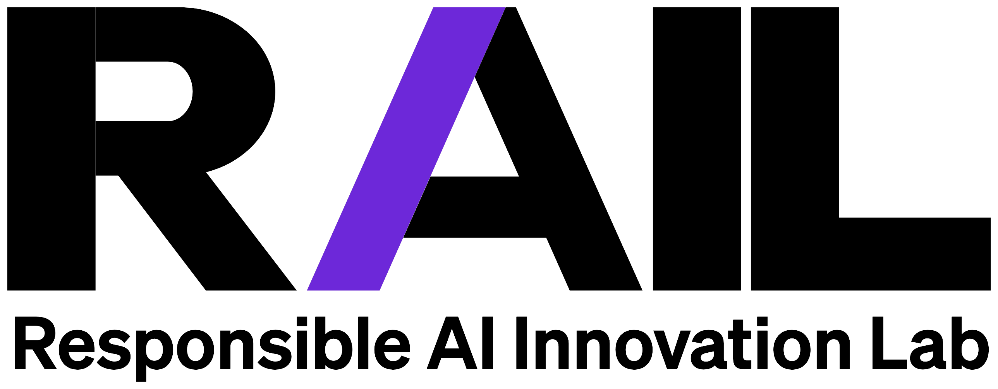
RESPONSIBLE AI BRIEF
Mapping the Marketing AI Regulatory Landscape
Where AI rules actually bind marketers, and the guardrails that keep you compliant
Current as of June 2026

THE BIG PICTURE
The map is moving faster than your planning cycle
AI rules now change faster than annual budgets, and in 2026 the two largest Western markets moved in opposite directions: the United States pulled regulation back, and the European Union let the hardest parts of its own AI Act slip. Neither landed somewhere steady.
This brief is a practical map, not legal advice. It covers where AI regulation actually binds a marketing organization today, region by region and sector by sector, and ends with a one-page compliance checklist you can run against your own program.
The takeaway
Govern to a standard higher than any single jurisdiction currently requires. The requirements move faster than planning cycles, and the US ones are now political rather than purely legal, so a single internal bar pegged to the strictest market you touch is cheaper than tracking fifteen regimes.

UNITED STATES · THE DIRECTION
From governance, to deregulation, to security
For a decade the United States was the hands-off counterweight to Brussels. Under the Biden administration that came with a qualifier: innovation first, but paired with guardrails aimed at societal harm. The 2023 executive order on AI, the NIST AI Risk Management Framework, and active agency attention to algorithmic discrimination set the tone.
The Trump administration reversed that in 2025. It rescinded the prior order, replaced it with a framework built around "American AI dominance," directed agencies to strip references to misinformation, bias, and climate from federal AI guidance, and pulled back FTC enforcement on algorithmic harm. The throughline is deregulation, and specifically the removal of the societal-impact lens.
What has returned since is not a revival of consumer protection. It is security. The federal moves that have appeared — frontier-model security review, tighter export controls, and ad hoc interventions such as the brief 2026 export-control shutdown of a leading model over a security finding — are driven by national-security and competitiveness concerns, not by protecting the public from AI's everyday harms. The same administration that said American AI should be the world's golden standard has leaned into export restrictions rather than open diffusion.
What this means for a marketer
Expect less federal regulation overall; expect what does arrive to be security-shaped rather than rights-shaped; and expect volatility. An incident or a trade negotiation can change your vendor's model availability with little notice, so treat US federal policy as weather, not climate.

UNITED STATES · THE STATE PATCHWORK
Where the binding obligations still live
With Washington unwilling to legislate and actively trying to preempt the states, the binding rules for most US marketers still come from the states, and they fragmented further this year.
Colorado | Repealed its risk-based AI Act before it took effect and replaced it with a lighter disclosure-and-rights model (effective Jan 2027), dropping the EU-style algorithmic-discrimination duty of care. A signal that the EU template is not becoming the US default.
California | Training-data transparency (AB 2013) took effect Jan 2026; the frontier-AI safety disclosure law (SB 53), signed Sept 2025, is the first enforceable US frontier-AI law.
New York | The RAISE Act (frontier-AI safety) was signed March 2026, effective Jan 2027.
Illinois | An amendment barring discriminatory AI in employment took effect Jan 2026; a frontier-AI accountability bill passed both chambers in May 2026.
Texas, Tennessee, Utah | Texas's Responsible AI Governance Act (effective Jan 2026) is heaviest on government use, with narrower private-sector bans on unlawful discrimination and manipulation. Tennessee's ELVIS Act (voice/likeness) and Utah's AI Policy Act remain in force.

Roughly 100 AI measures were enacted across 38 states in the 2025 session alone (NCSL). The operating reality for a national marketer is multi-state compliance to the strictest applicable standard, with the added uncertainty that Washington is trying to invalidate some of these laws in court.

EUROPEAN UNION
The rules arrived, then the hardest parts slipped
The EU AI Act is in force, but its timeline moved this year. For marketers serving EU consumers, the transparency and content-labeling duties are the live ones today.
- Prohibited practices (Art. 5) have applied since Feb 2025.
- General-purpose AI obligations have applied since Aug 2025: transparency, copyright compliance, and safety duties for systemic-risk models. Enforcement powers and fines (up to €15M or 3% of turnover) begin Aug 2026.
- High-risk system rules were due Aug 2026, but the Digital Omnibus pushed standalone high-risk duties to Dec 2027 and product-embedded ones to Aug 2028. Until that adoption is final, August 2026 remains the live statutory deadline, so treat it as binding for now.
- The AI Liability Directive was withdrawn (Oct 2025); AI-harm liability now falls to the revised Product Liability Directive plus 27 national regimes.
- A Code of Practice on labeling AI-generated content (Art. 50) was published June 2026, directly relevant to generative marketing output.
- Italy is the first member state with its own AI statute and criminal deepfake provisions.
For EU-facing marketers
The GPAI transparency and content-labeling obligations are live today. The high-risk delay bought you runway; the labeling rules did not.

THE REST OF THE WORLD
Comprehensive laws, light-touch frameworks
United Kingdom | No AI Act; a sector-based, pro-innovation model. The competition and data regulators (CMA, DRCF) have published some of the most developed agentic-AI consumer guidance anywhere.
South Korea | The comprehensive AI Basic Act takes effect Jan 22, 2026 — the second comprehensive AI law after the EU, with criminal penalties available.
China | No single statute, but a deepening layer of targeted rules: mandatory AI-content labeling, deep-synthesis and recommendation-algorithm rules, and dedicated AI-agent guidance. State-controlled and fast-moving.
Singapore & Japan | Singapore leads on practical governance frameworks (including agentic AI) without heavy legislation; Japan's AI Promotion Act is promotion-only, with no penalties.
Canada | AIDA died with the prorogation of Parliament (Jan 2025); no replacement yet, so AI is governed under the existing federal privacy law.
India & GCC | Both favor guidance over legislation. India issued voluntary responsible-AI principles plus mandatory labeling of synthetic content; Gulf states (UAE, Saudi Arabia) pair national AI strategies with ethics principles and heavy investment, light regulation.
Brazil | A risk-based bill passed the Senate (Dec 2024) and remains pending in the lower house.

SECTOR RULES & COPYRIGHT
Where regulated industries add a layer
Marketers in financial services and healthcare carry obligations beyond the general laws above:
- Financial services. AI used for credit, insurance, or eligibility must satisfy anti-discrimination law (e.g. the Equal Credit Opportunity Act) and explainability expectations; regulators may require bias audits and a human override.
- Healthcare. Privacy law (HIPAA in the US) strictly governs patient data, so any AI touching it in a marketing context must protect it and use it only for authorized purposes; AI that edges into medical advice can trigger health-regulator or FDA oversight.
Copyright and training data
- AI output alone is not copyrightable — human authorship is required (US Copyright Office, 2025; Thaler, DC Circuit).
- Training on copyrighted work is unsettled. Bartz v. Anthropic produced a $1.5B settlement and held that storing pirated books is separate infringement; Kadrey v. Meta found shadow-library training fair use. More trials are pending.
- Disclosure is arriving via the states (California's AB 2013; a New York bill awaiting signature).
Practical posture
Assume AI-generated assets carry weak or no copyright protection, keep humans demonstrably in the creative loop on anything you need to own, and treat training-data provenance as a vendor due-diligence question.

THE CHECKLIST
Cross-market compliance checklist
Adopt these eight guardrails and you meet or exceed the binding requirements in the markets most global marketers operate in. Tick them off against your own program.
☐ Disclose AI to the people it touches. Tell customers and employees when they are interacting with, or being evaluated by, AI.
☐ Label AI-generated content. Mark synthetic images, video, and copy — the live EU and state rule most likely to catch marketing output.
☐ Keep a human accountable for consequential decisions. No fully automated decision with significant personal or legal impact without documented human review.
☐ Run a risk and bias assessment on high-impact uses before launch, and keep the record.
☐ Minimize and classify data. Use the least sensitive data that does the job, and control which data classes can enter which tools.
☐ Honor data rights and opt-outs — access, deletion, and the right to decline automated processing.
☐ Document training-data provenance for any model you build or buy, and make it a procurement question.
☐ Keep audit logs of consequential AI actions, with an owner who can answer for them.
Where this gets you covered
Follow these and you are broadly compliant with the EU AI Act's marketing-facing duties, the major US state laws, and the UK, Canadian, Singaporean, and South Korean frameworks. They will not make you compliant with China's state-specific content and algorithm regime, which is a separate system most Western marketers only need to engage if they operate there. When in doubt, the EU bar is the safest single standard to build to.

WHAT TO DO
Five moves to make now
1. Govern to the strictest standard you touch
A single internal bar pegged to the highest applicable requirement (usually the EU) is cheaper than tracking a dozen regimes.
2. Treat US federal policy as weather, not climate
An incident or a trade negotiation can change your vendor's model availability overnight. Keep a fallback.
3. Label generative output now
EU content-labeling and multiple state disclosure rules are already live or imminent.
4. Make training-data provenance a procurement question
The copyright answer is coming from courts; your exposure runs through your vendors.
5. Run the checklist quarterly
The eight guardrails change slowly even as the laws churn. Re-check them each quarter and you stay ahead of most of the movement.
This document is a practical map, not legal advice. Confirm specifics with counsel for the jurisdictions you operate in. Published by MMA's Responsible AI Innovation Lab (RAIL) and the AI Leadership Think Tank.

